CURRICLUM VITA

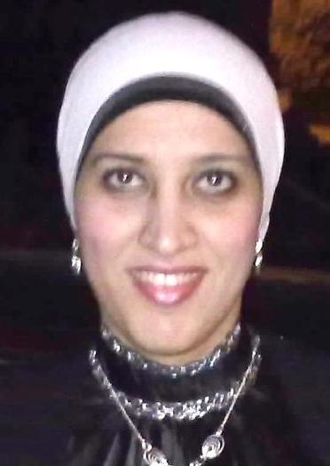

## PERSONAL DATA

Name: Noura Fathy Abd El Salam

Present Position: Lecturer in the Chemical Engineering Department

Affiliation: faculty of engineering, Cairo University

Field of Specialization: chemical engineering

Telephone: (Home) 0244694876 (Mobile) 01012214655

E-Mail: nourafathy_1983@hotmail

Date of Birth: 23/8/1983

Nationality: Egyptian

## ACADEMIC QUALIFICATIONS

1. B. Sc. In. Chemical engineering
2. M.Sc in Nuclear engineering

.

Thesis Title: RISK BASED SITING FOR THE EGYPTIAN NUCLEAR POWER STATION

1. Ph.D. in. inorganic technology

Thesis Title: THE USE OF FACTORIAL DESIGN IN OPTIMIZING THE EXTRACTION OF ALUM FROM EGYPTIAN KAOLIN CLAY

#### PROFESSIONAL EXPERIENCE

Name of Employer Duration Position Held

##### M.Sc and PH.D SUPERVISED

##### … awarded M. Sc and … Ph. D; … M. Sc and … Ph. D under supervision.

##### TEACHING EXPERIENCE

1. Undergraduate Courses thermodynamics , physical chemistry, mechanical unit operations, inorganic technology
2. Postgraduate Courses
3. B.Sc. PROJECTS SUPERVISED

**Patents and Publications**

N.F. ABDEL SALAM**,THE USE OF FACTORIAL DESIGN IN OPTIMIZING THE PRODUCTION OF ALUM FROM EGYPTIAN KAOLIN CLAY, JEAS, Vol. 60, Issue 6, pages 601-616, December 2013**

###### PROFESSIONAL ACTIVITIES

.

**AWARDS**

**Area of Research:**