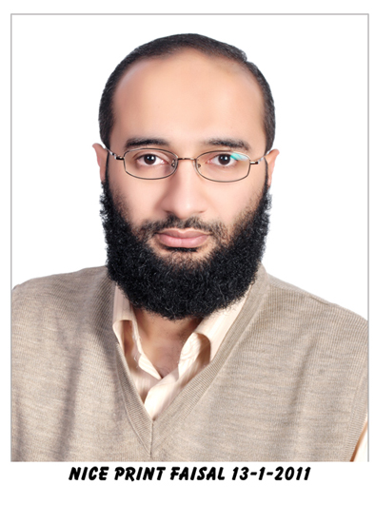
Resume 24th October 2015

Ahmed Mohamed Rashed DESOKI
Summary | I'm Mechanical/Aerospace engineering assistant professor specialized in experimental vibration and acoustics. I got familiar with some Communications engineering concepts during my graduate research. I’m experienced with scientific research, technical writing, academic teaching, scientific computing and simulations, CAD/CAE software packages and a number of programming languages.
Nationality | Egyptian
Birthday | June, 4, 1978
Current Job | Assistant professor  Aerospace Engineering Dept.,  Cairo Univ., Egypt
Gender | Male
Phone/fax | Mobile: ++20 (114) 157-0758
e-mail | ahmed.m.rashed@gmail.com
Educational History | - B.Sc., Aerospace Engineering, Cairo University, Egypt, 2000  - M.Sc., Aerospace Engineering, Cairo University, Egypt, 2004  - Doctor of Engineering, Mechanical Engineering, Tokyo Institute of Technology, Japan, November 2009
Employment History | - (Jan. 2011 – present) Assistant Professor, Aerospace Engineering Dept., Cairo Univ., Egypt  - (Apr. 2009 – Sept. 2010) Systems Engineer, Simulation Engineering Department, Digital Process Ltd., Fujitsu Limited; Japan, www.dipro.co.jp  - (May 2008 – Mar. 2009) Researcher, Tokyo Institute of Technology, Japan  - (Oct. 2007 – Apr. 2008) Software Engineer, InterLocus, Inc., Tokyo Institute of Technology venture company, Japan  - (Oct. 2004 – Dec. 2010) Lecturer assistant, Aerospace Engineering Dept., Cairo Univ., Egypt  - (Jan. 2003 – Sept. 2004) Advisor of “Modal Analysis and Experimental Vibration laboratory”, Aerospace Engineering Dept, Cairo Univ., Egypt  - (Jan. 2001 – Sept. 2004) Advisor of “Structural Analysis CAE Laboratory”, Aerospace Engineering Dept, Cairo Univ., Egypt  - (Aug. 2000 – Sept. 2004) Teaching Assistant, Aerospace Engineering Dept, Cairo Univ., Egypt
Scientific Experience | - Mechanical vibration (both analytical and experimental)  - Sound source localization (both theoretical and experimental)  - Digital signal processing  - Sensor array signal processing  - Packaging industry (Vertical packaging machine design)  - Finite Elements  - Aircraft Structures  - Design Optimization  - Scientific computing  - CAD/CAE
Courses Taught | - Aviation Legislation  - Analysis of Structures I & II  - Mechanics of Structures I & II  - Dynamics of Structures  - Experimental Modal Analysis  - Applied Signal Processing  - Experimental Methods in Aerospace Engineering  - Computer Applications
Computer Skills | - NX/MD/MSC Nastran  - Siemens NX  - Modeling  - Advanced Simulation  - API programming using C/C++  - MD/MSC Patran  - API programming using Patran Command Language (PCL)  - FEMAP  - I-DEAS  - Test  - SolidWorks  - Autocad/Autocad Mechanical  - LMS CADA PC | - Matlab  - C\C++  - Fortran  - Visual Basic for Applications (VBA)  - Python  - Maple  - Visual Basic  - LaTeX  - Linux
Language Ability | - Arabic (Egyptian): Native level  - Arabic (Formal): Native level  - English: Very good  - Japanese: Good  - German: Poor
Qualifications/  Licenses | - Maintenance Basics for Aeronautical Engineering, EgyptAir Training Division, Egypt (2000)  - TOEFL: 247 (2002)  - CanSat Leadership Training Program (CLTP) (2012)
Publications | Peer Reviewed  - A. Desoki, H. Morimura and I. Hagiwara, “General Design of the Forming Collar of the Vertical Form, Fill and Seal Packaging Machine Using the Finite Element Method,” Packaging Technology and Science, vol. 24, pp. 31-47, 2011.  - A. Desoki, J. Takada and I. Hagiwara, “Improved finite samples resampling for unbiased wide-band direction of arrival estimation,” Acoustical Science and Technology, vol. 30, no. 6, pp. 417-428, 2009.  - A. Desoki, J. Takada and I. Hagiwara, “Efficient array design algorithm for wide-band application of the MUltiple SIgnal Classification algorithm,” Acoustical Science and Technology, vol. 30, no. 3, pp. 187-198, 2009.  Abstract Reviewed  - A. Desoki, Improved finite samples resampling method for unbiased wide-band direction of arrival estimation, in International Workshop on Acoustics and Vibration - IWAVE 2011.  - A. Desoki, I. Hagiwara and Q. Shi, “Determination of absolute pressure amplitudes using Beamforming,” in 2005 Autumn Meeting of Acoustical Society of Japan, 2005, pp. 1351-1352, Sendai, Japan, September 2005.  - S. Talaat, A. Desoki, M. Tawfik, and H. M. Negm, “Experimental and Numerical Investigation of the Capabilities of Periodic Plates for Vibration Attenuation”, 20th International Congress on Sound and Vibration- ICSV20, 2013.  Technical Reports  - A. Desoki, “Experimental modal analysis of the horizontal tail unit of a jet trainer,” Technical report, CUFE/AE/TR-002/04, Aerospace Engineering Department, Cairo University, Feb. 2004.  - A. Desoki, “Experimental modal analysis of a plate,” Technical report, CUFE/AE/TR-001/04, Aerospace Engineering Department, Cairo University, Jan. 2004.

